**Law Enforcement Computer Aided Dispatch (CAD) Systems**

**Coarse-Grained Plan**

1. For the Law Enforcement Computer Aided Dispatch Systems, we are going to use one of the unified modeling language diagrams which is “RUP”.

RUP is rational unified process which consists of four phases namely inception, elaboration, construction and Transition

The artifacts used in the process would help in describing in depth about the design, function, and architecture of the software.

For the overall project the following are the various artifacts which can be developed

**Inception:** This phase contains the artifacts:

Requirements Management Plan

* Call Classification and Priority
* Check for duplicate calls
* Security

**Elaboration:** This phase contains the artifacts:

User-Interface Guidelines

* Communication Interfaces
* Locational System Interfaces
* Emergency Operation Interfaces

Use- case Modeling Guidelines

* Retrieve incoming calls
* Review Call background information
* Dispatch resource decision

Risk Management Plan

* Geofile Maintenance
* Logging
* Table maintenance

**Construction:** This phase contains the artifacts:

Test Guidelines

* Call Recording
* Training and Testing

Law Enforcement CAD System is too sophisticated that each and every function should work at its peak performance so in order to handle such a large and sophisticated system we need High Level Ceremony, this means we need a proper supporting documentation and traceability maintained between artifacts.

The complexity of the system is well understood through the RUP as it apart from visualizing the dynamic nature of a system it also constructs the executable system by using forward and reverse engineering techniques. The requirement specification document deals with various business functions which can be captured altogether and it furthermore describes the flow from one phase to another.

|  |  |  |  |  |  |  |  |
| --- | --- | --- | --- | --- | --- | --- | --- |
| **Component**  **Name** | **Type**  **(ILF, EIF, EI, EQ, EO)** | **DETs**  **(list)** | **DETs**  **(count)** | **RETs** | **FTRs** | **Complexity**  **(L, A, H)** | **FPs** |
| RMS(Record Management system) Database | Interface  Logical File(ILF) | Person Name, Date, Time, Location, Nature of Complaint, Priority, Vehicle Number, Date of Expiry, Status, Contact Info | 10 | 1 | - | Low | 7 |
| Create | External Input(EI) | Nature of Complaint, Priority, Date, Date of Expiry, Person Name, Vehicle Number, Contact Info. | 7 |  | - | Low | 3 |
| Search | External Inquires  (EQ) | Person Name, Nature of complaint, Contact Info, Date, OK | 5 |  | 1 (RMS Database) | Low | 3 |
| Delete | External Input  (EI) | Person Name, Contact Info, Date, Date of expiry, Nature of Complaint, Delete. | 6 |  | 1(RMS Database) | Low | 3 |
| View | External Inquiries (EQ) | Date, Date of Expiry, Contact Info, View | 4 |  | 1(RMS Database) | Low | 3 |
| Generate Report | External Output(EO) | Person Name, Date, Time, Location, Nature of Complaint, Priority, Vehicle Number, Date of Expiry, Status, Contact Info, Equipment. | 11 |  | 1(RMS Database) | Low | 4 |

The total function point count is 483.

1. Estimation of cost and effort

* Sizing Method – Function Points
* Software Size (Function Point) – 483
* Language – JAVA
* Software Scale Drivers – Nominal
* Cost Drivers – Nominal
* Software Labor Rates

(Cost per Person-Month $$$) - $5000

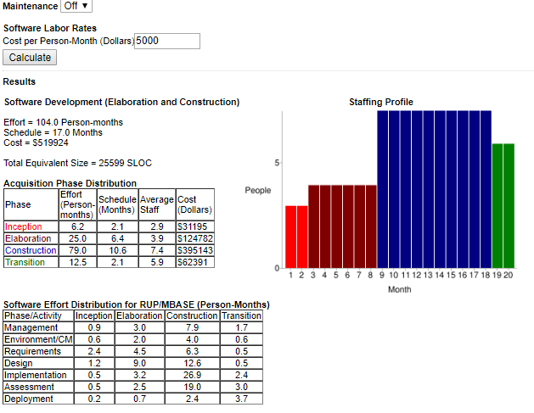

|  |  |  |  |  |  |
| --- | --- | --- | --- | --- | --- |
|  | Name | Duration | Start | Finish | Predecessors |
| 1) | Requirements | 64days | 12/06/18, 9am | 02/08/19, 5pm |  |
| 2) | Preliminary Design Review | 64days | 12/06/18, 9am | 02/08/19, 5pm |  |
| 3) | User Interface Modules | 194days | 02/09/19, 9am | 08/22/19, 5pm |  |
| 4) | Use cases Modeling | 194days | 02/09/19, 9am | 08/22/19, 5pm |  |
| 5) | Test phase | 322days | 08/23/19, 9am | 07/09/20, 5pm |  |
| 6) | System Testing | 322days | 08/23/19, 9am | 07/09/20, 5pm |  |
| 7) | Risk Estimation | 194days | 02/09/19, 9am | 08/22/19, 5pm |  |
| 8) | Risk Mitigation | 322days | 08/23/19, 9am | 07/09/20, 5pm |  |
| 9) | Deployment phase | 64days | 07/10/20, 9am | 08/12/20, 5pm |  |
| 10) | Operational Phase | 64days | 07/10/20, 9am | 08/12/20, 5pm |  |

1. The total development of the project should take 20months.

|  |  |
| --- | --- |
| Months | Num of Developers |
| 0-2 | 3 |
| 3-8 | 4 |
| 9-18 | 7 |
| 19-20 | 6 |

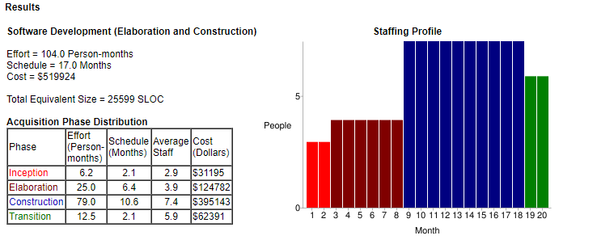

1. The Law Enforcement agencies have moved to Computer Aided Dispatch (CAD) Systems which makes it automated. This involves the risk of sharing the data which can be compromised or lost its integrity. Therefore, the Law Enforcement Information Sharing Program developed by U.S Department of Justice makes sure to promote information sharing among all the levels of the law enforcement community securely in a timely manner.

If the schedule and the budgets don’t go hand in hand and even the effort are not efficient enough then the risk of project failure is high. Requirements if not well defined initially would result in missing values.

Timely analysis at every phase and iteration and managing the records of these updates would give better insight to future risks and prevention of risks.

**Fine-Grained Plan**

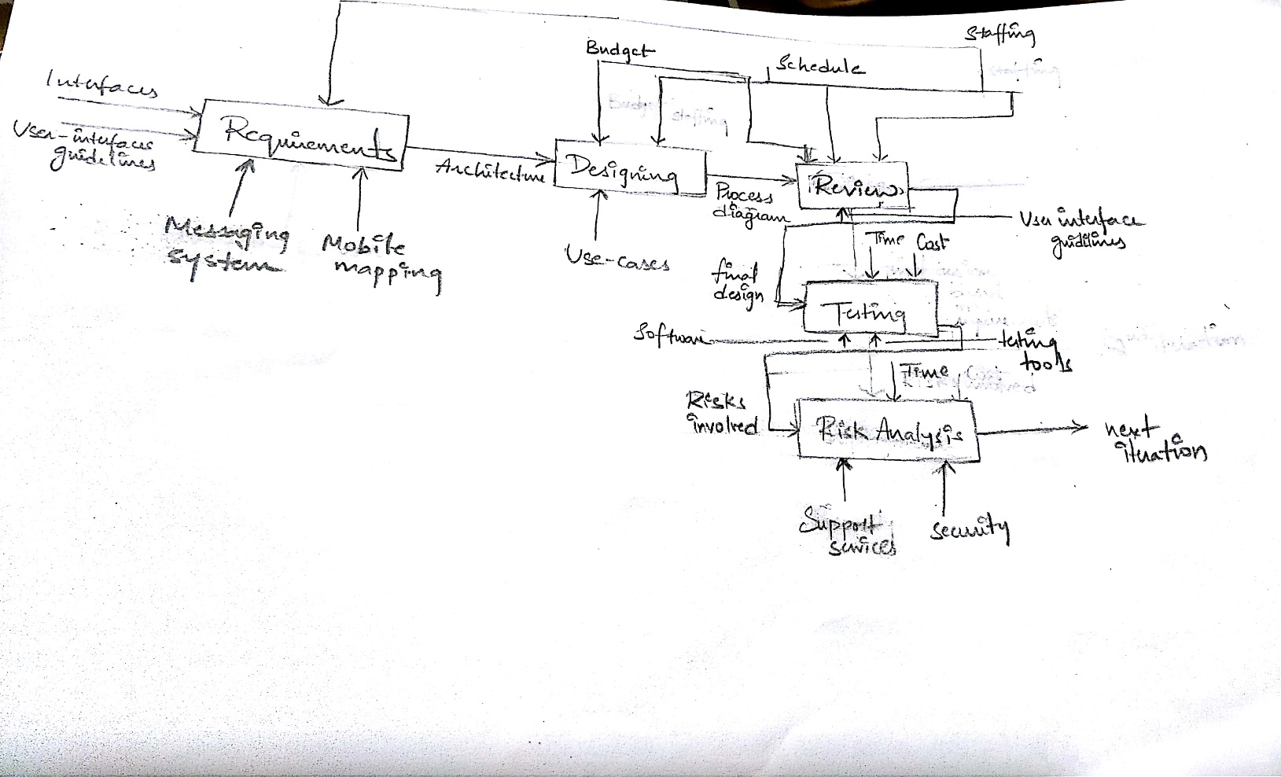

**2)** Gantt Chart

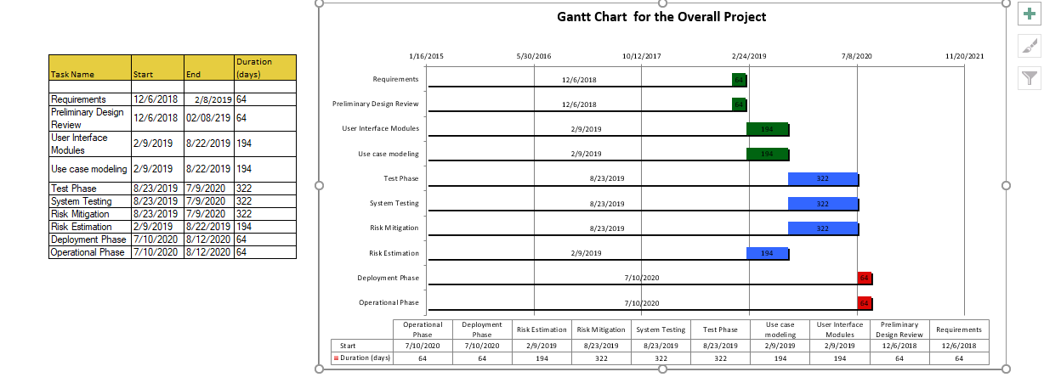

1. Tasks allocated to each resource.

|  |  |  |
| --- | --- | --- |
| Resource Names | Tasks | Duration |
| Developer 1 | Requirements, Planning, Designing, Review, User interface, Use cases, Risk Analysis, Test phase, System testing | 64days + 192days + 322days |
| Developer 2 | Requirements, Planning, Designing, Review, User interface, Use cases, Risk Analysis, Test phase, System testing | 64days+194days+322days |
| Developer 3 | Requirements, Planning, Designing, Review, Risk Analysis, Test phase, System testing | 64days+194days+ 322days |
| Developer 4 | User interface, Use cases, Risk Analysis, Test phase, System testing, Risk Mitigation, Deployment, Operational | 194days + 322days + 64days |
| Developer 5 | Risk Mitigation, Deployment, Operational, Test phase, System testing, | 322days + 64days |
| Developer 6 | Test phase, System testing, Risk Mitigation, Deployment, Operational | 322days + 64days |
| Developer 7 | Test phase, System testing, Risk Mitigation, Deployment, Operational | 322days + 64days |
| Developer 8 | Test phase, System testing, Risk Mitigation, Deployment, Operational | 322days + 64days |
| Developer 9 | User interface, Use cases, Risk Mitigation, Deployment, Operational | 194days + 64days |